**Maven Java Project**

1. Create EC2 Instance and allow all traffic Than change to root and install git,Docker and start docker,Check Docker Client Version is running or not .







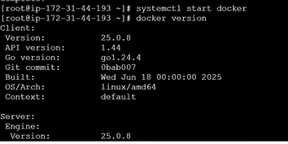

1. First Clone the Project and docker file should be inside the project.

Project Link:- **https://github.com/CloudTechDevOps/project-1-maven-jenkins-CICD-docker-eks-.git**

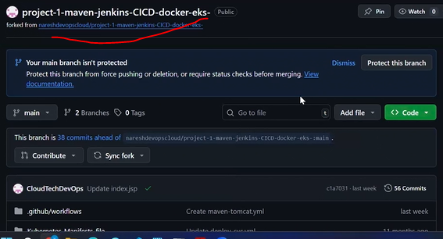

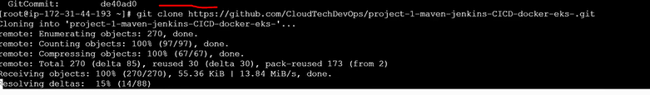

1. Then change to project directory.

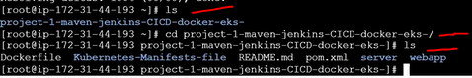

1. Than delete Kubernetes file.



**Dockerfile Part-1**

1. From the existing Dockerfile we have so many stages one by one and we commented all those lines. Uncomment Stage and Stage than Proceed one by one.

If You want you don’t go with existing. You will go with New Dockerfile than Copy the existing code than delete existing file than create new one and go existing code one by one.



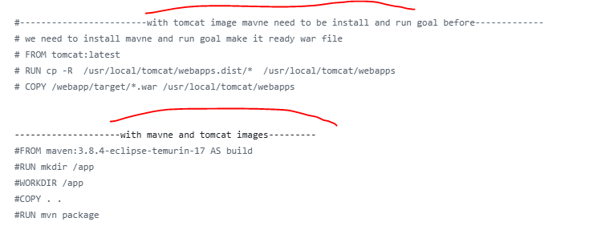

1. Download Tomcat and Copy War file from Target to Destination(Tomcat Deploy path).



1. Now Install Maven in EC2 Linux/Ubuntu Server. When maven will install than automatically Java will install. We can can version as well.



1. To Create a War/Jar than execute maven command.



1. After success please check war file is created or not.

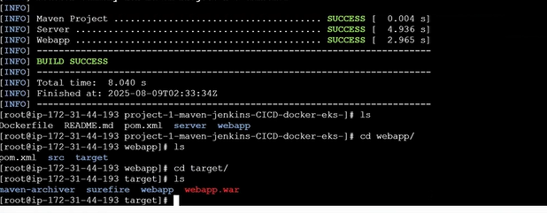

1. Than back to project path and build the docker file to create image.

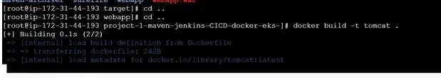

1. Now Check Images are created or not.

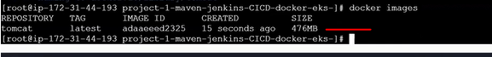

1. Now we will run the image in container. We are not provided the CMD to run in our Dockerfile but it will run default CMD Path given in Tomcat image which one we pull from Docker Hub. If we want to insect image as what is the value in CMD on tomcat image. Than **docker insect imageName**

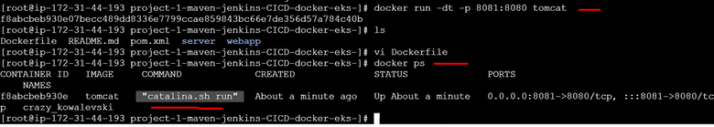

1. Than check its running or not.

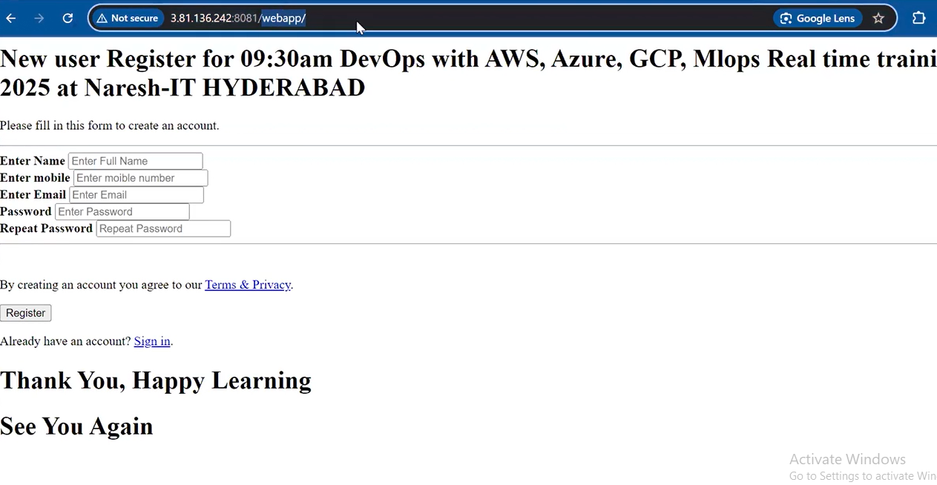

1. It will not run in default path because content present in **webapp.dist** but not present in **webapps**. So we need to move the content to that folder than it will run in default port.

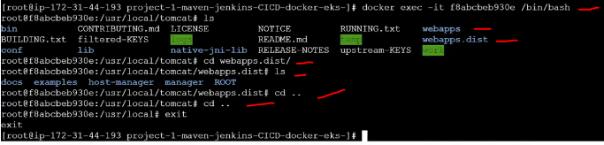

1. Forcefully stop the process and delete the image. Also Remove Maven and Clear the created war file.

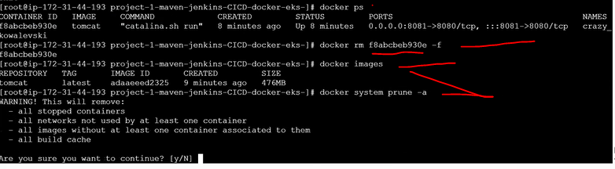

**Dockerfile Part-2**

1. We will execute everything above steps in Docker. So below is our docker file. Taking Entire Maven process as build. Tomcat is depend on build.

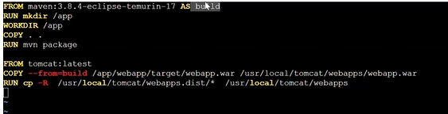

1. Now we will build and create image.

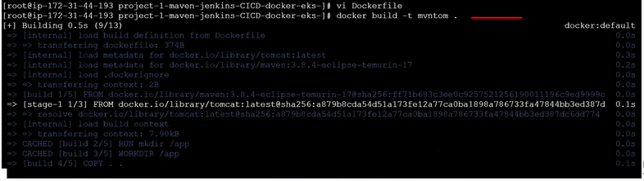

1. Check Images and run the container. So that we can able to run our app. We can see also default page and webapp also. Before it not present inside webapps and now its moved.

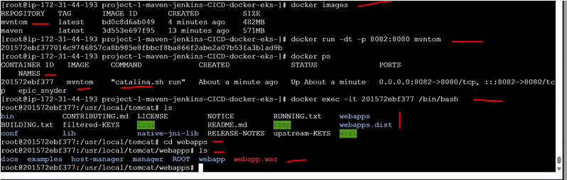

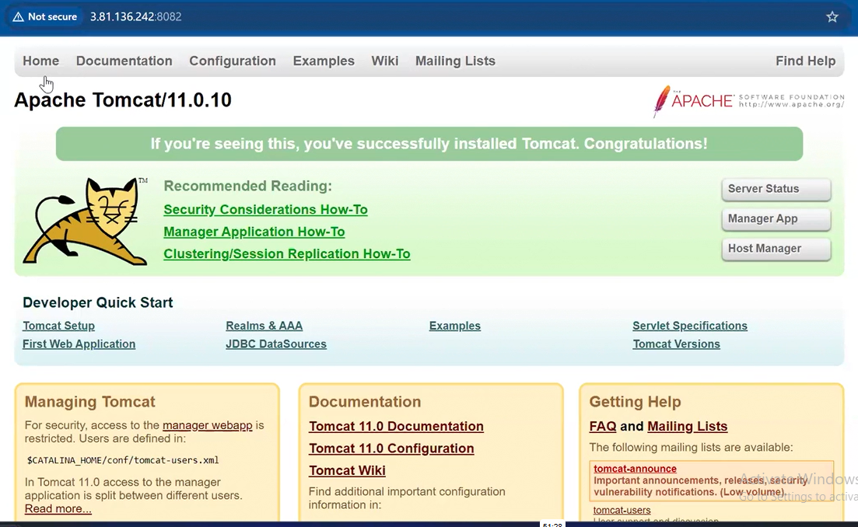

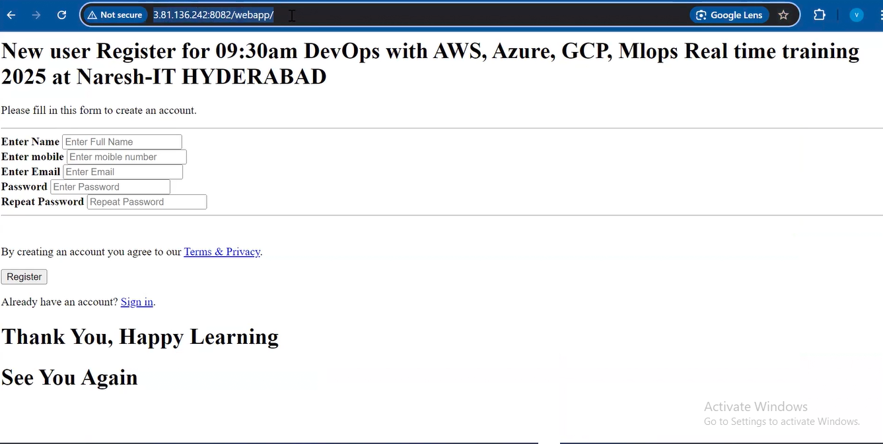

1. In This docker file we have so many docker automate Please have a look the code.
2. **How We will Push the image to Docker Hub Or ECR.**

Now We have 2 images.



Will Push to ECR.

1. First Create a Repository in ECR. Reository Name should be same with Image Name.

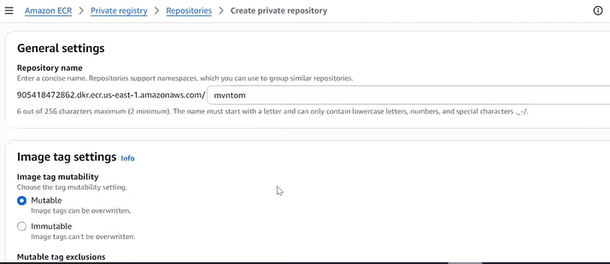

1. Click

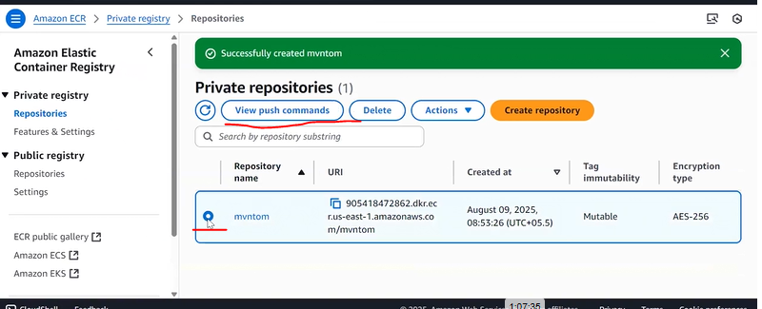

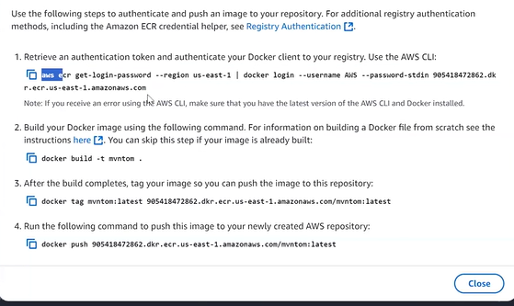

1. Before pushing image to ECR we need to create IAM Role for EC2 instance. Role for EC2.

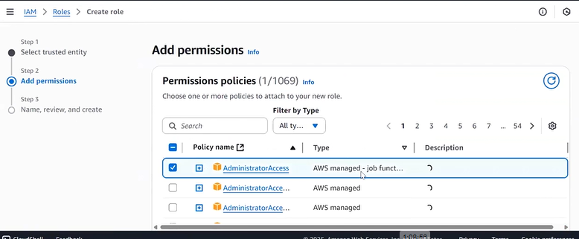

And attach to EC2.

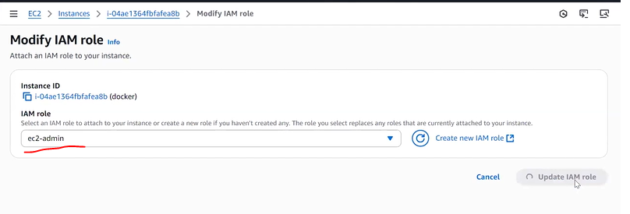

1. Than execute below commands.

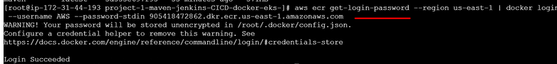



Than check its Taged.

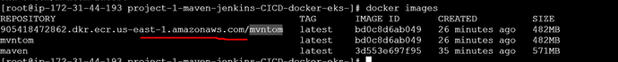

Than Push Image to ECR.

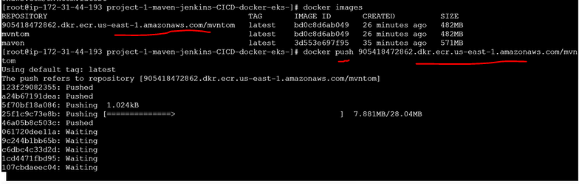

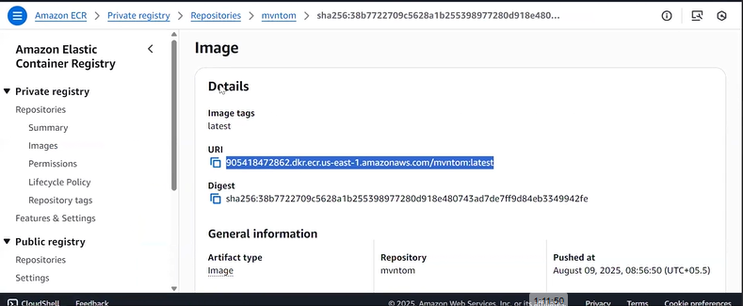

1. If We are run this process in Jenkins than we need to delete existing image than push new image.
2. Docker Hub Sign Up and Push Image.